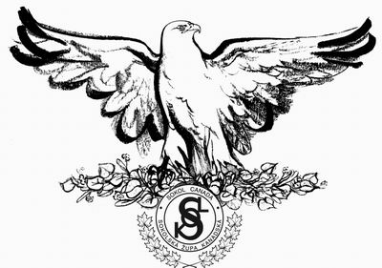

BŘEZEN – MARCH

LETOS JE TO 190 LET CO SE 2.3.1824 NARODIL SLAVNÝ ČESKÝ SKLADATEL BEDŘICH SMETANA - MÁ VLAST, LIBUŠE, PRODANÁ NEVĚSTA

IT IS 190 YEAR SINCE CZECH COMPOZER BEDRICH SMETANA WAS BORN.
HE COMPOSED – MY HOMELAND, OUT OF MANY OPERAS LIBUSE AND BARTERED BRIDE

SOKOL 4.3.1827 se narodil MUDR. Eduard Grégr, druh M.Tyrše, spoluzakladatel
Sokola a jeho první jednatel – was born, friend of M.Tyrs, cofounder of Sokol and first secretary.
19.3.1845 se narodila Klemeňa Hanušová spolupracovnice M.Tyrše, zakla-
datelka ženského tělocviku, první cvičitelka a náčelnice 1869 –
1896 - was born, coworker of M.Tyrs, founder of women gym,
first instructor of women and director 1869 – 1896.
24.3.1889 První sjezd sokolstva a ustanovení České obce sokolské
First congress of sokol members and foundation of ČOS
-------------------------------------------------------------------------------------------------------------------------------

ZNÁMÉ OSOBNOSTI – WELL KNOWN PEOPLE
2.3.1824 se narodil hudební skladatel Bedřich Smetana – was born
3.3.1853 se narodil maliř Vincent Van Gogh – painter was born
3.3.1854 se narodil Leoš Janáček ,Český hudební skladatel – was born
Czech composer – Její patorkyňa ( Jenůfa) , Věc makropulos
7.3.1850 se narodil T.G.Masaryk, první president Československa -
was born first president of Czechoslovakia
14.3.1879 se narodil fyzik Albert Einstein – was born
18.3.1858 se narodil Ing.Rudolf Diesel vynálezce spalovacích motorů
was born inventor of diesel motors.
28.3.1592 se narodil Jan Amos Komenský – was born

-------------------------------------------------------------------------------------------------------------------------------

MARCH 15. 1939 75 anniversary of German invasion of Czechoslovakia

